**Installation of Executable file:**

Dependency 🡺 Executable file can only run on Windows System

There is an executable file, first of all open that file,

A window will be appeared there, Set the destination where user wants to install it.

Then click next and installation will be started, and at last click on Finish.

Go to folder where it is installed, click on application file,

Application will be opened.

Only 1 player can be controlled by the user,

Other players will be the system players.

Here is the UI layout of the game.

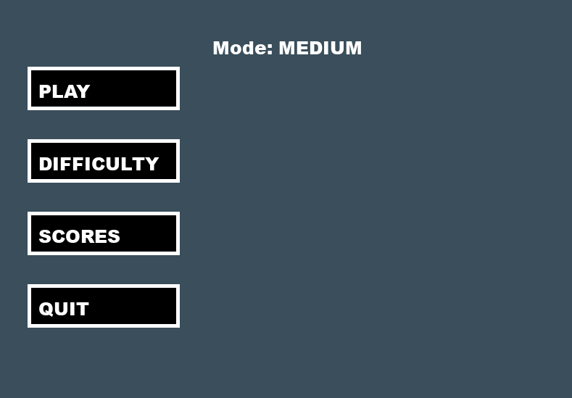

User can select the difficulty level from here

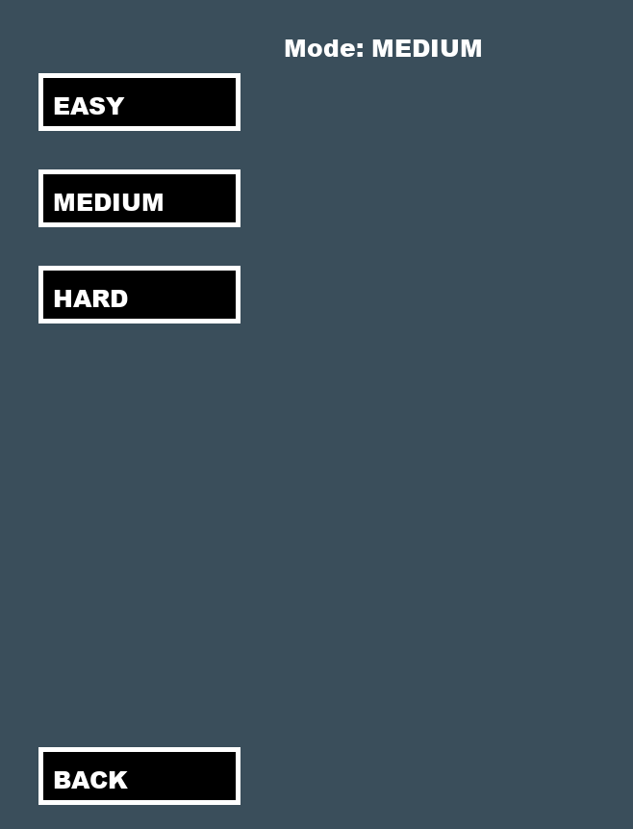

User can select grid size from here in Medium and Hard level

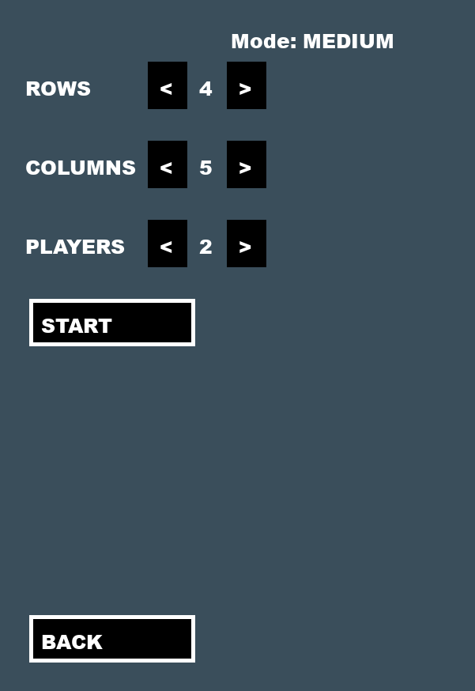

If difficulty level is Easy then user will have by default only 3 options.

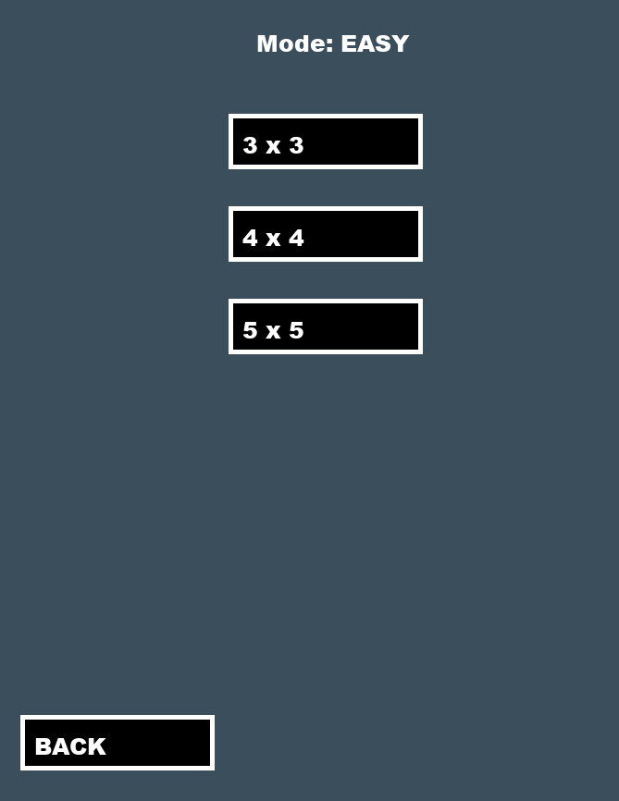

This is the Grid of the game

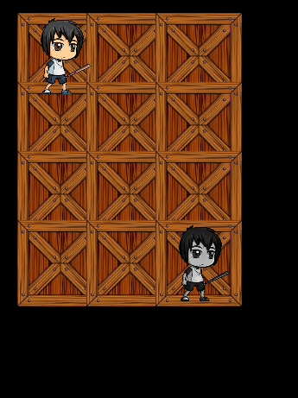

When both players will reach at same point game will end and come back to previous menu.